Name : Khush Pithva 24BCE174
Subject : Data Structure (2CS501)
Practical no.:10(A)
AIM : Write a program to implement Selection and Quick sort for sorting a given set of integers in ascending order and also calculate time complexity.

INPUT :
#include<bits/stdc++.h>
using namespace std;

void printArray(int arr[], int size) {
for (int i = 0; i < size; i++) {
cout << arr[i] << " ";
}
cout << endl;
}
void selectionSort(int arr[], int n) {
for (int i = 0; i < n - 1; i++) {
int min_idx = i;
for (int j = i + 1; j < n; j++) {
if (arr[j] < min_idx) {
min_idx = j;
}
}
if (min_idx != i) {
swap(arr[min_idx], arr[i]);
}
}
}
int partition(int arr[], int low, int high) {
int pivot = arr[high];
int i = (low - 1);

for (int j = low; j <= high - 1; j++) {
if (arr[j] < pivot) {
i++;
swap(arr[i], arr[j]);
}
}
swap(arr[i + 1], arr[high]);
return (i + 1);
}

int main() {
int original_arr[] = {64, 34, 25, 12, 22, 11, 90, 5};
int n = sizeof(original_arr) / sizeof(original_arr[0]);

cout << "Original Array: ";
printArray(original_arr, n);
cout << "\n";

int arr_for_selection[n];
copy(original_arr, original_arr + n, arr_for_selection);

cout << "--- Sorting with Selection Sort ---" << endl;
selectionSort(arr_for_selection, n);
cout << "Sorted Array: ";
printArray(arr_for_selection, n);
cout << "\n";
cout << "Sorted Array: ";
printArray(arr_for_quick, n);
cout << "\n";

return 0;
}

OUTPUT :
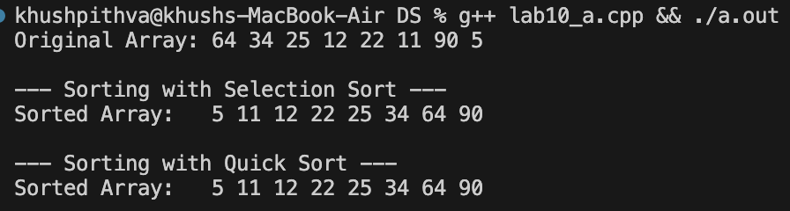

Practical 10 (B)
AIM : Write a program to implement Merge sort algorithm for sorting a given set of integers in ascending order and also calculate time complexity
INPUT :
#include<bits/stdc++.h>
using namespace std;

void merge(int arr[], int left, int mid, int right) {
int n1 = mid - left + 1;
int n2 = right - mid;

vector<int> L(n1);
vector<int> R(n2);

for (int i = 0; i < n1; i++) {
L[i] = arr[left + i];
}
for (int j = 0; j < n2; j++) {
R[j] = arr[mid + 1 + j];
}

int i = 0, j = 0, k = left;

while (i < n1 && j < n2) {
if (L[i] <= R[j]) {
arr[k] = L[i];
i++;
} else {
arr[k] = R[j];
j++;
}
k++;
}

while (i < n1) {
arr[k] = L[i];
i++;
k++;
}

while (j < n2) {
arr[k] = R[j];
j++;
k++;
}
}

void mergeSort(int arr[], int left, int right) {
if (left >= right) return;

int mid = left + (right - left) / 2;

mergeSort(arr, left, mid);
mergeSort(arr, mid + 1, right);

merge(arr, left, mid, right);
}

void printArray(int arr[], int size) {
for (int i = 0; i < size; i++) {
cout << arr[i] << " ";
}
cout << endl;
}

int main() {
int arr[] = {64, 34, 25, 12, 22, 11, 90, 5};
int n = sizeof(arr) / sizeof(arr[0]);

cout << "Original Array: ";
printArray(arr, n);

mergeSort(arr, 0, n - 1);

cout << "Sorted Array: ";
printArray(arr, n);

return 0;
}
OUTPUT :
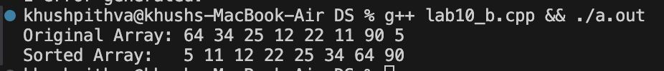

1.
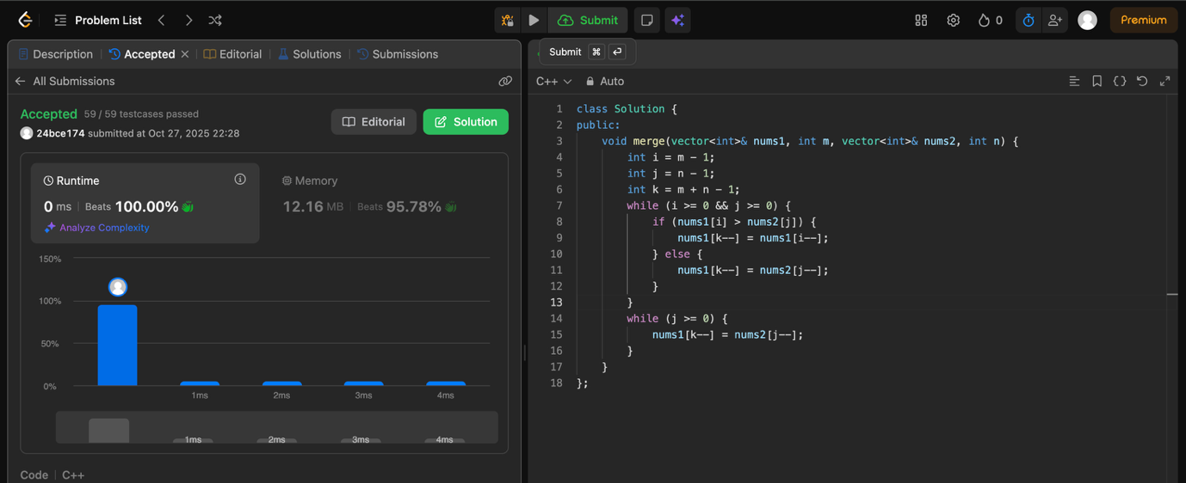

2.
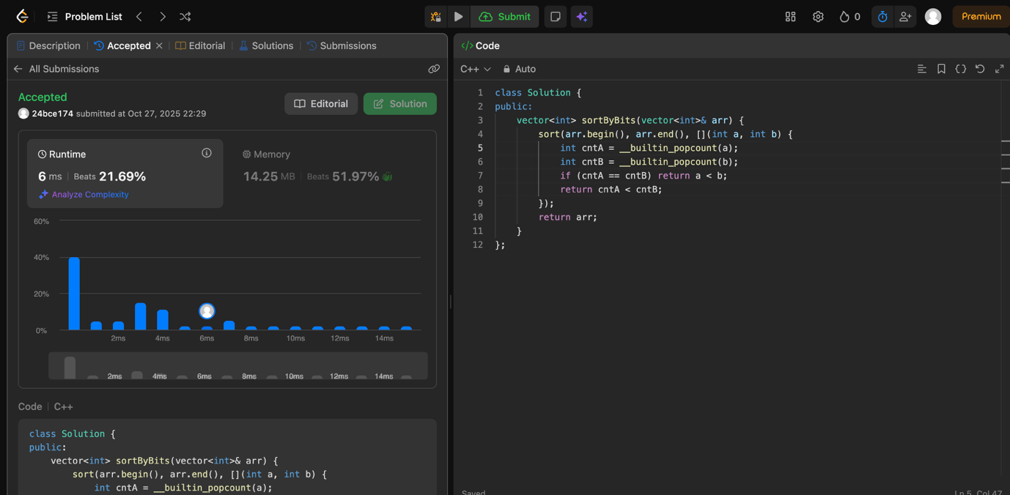

3.
